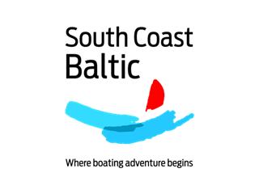

BOAT REGISTRATION FORM
South Coast Baltic Boating Rally 2019
Bornholm - Zachodniopomorskie - Vorpommern
4-14 August 2019
Please fill in & e-mail to info@southcoastbaltic.eu by 30 April 2019.
I will participate with my own ☐ Sailing boat
☐ Motor boat
Name of vessel:
Type of vessel / yard:
Year built:
Length over all:
Breadth:
Draught:
Engine : Power: kW HP
Port of registry:
Flag:
Radio call sign:
Owner:
Captain:
Address:
Phone:
E-mail:
Crew / no. of persons on board: (please fill in crew list, too – if possible)
Please help me to find a charter boat: ☐ Sailing boat
☐ Motor boat
Name:
Kind of boat searched for:
__________________________________________________________________
We plan to arrive in Svaneke on (day – dd.mm.)
We plan to leave from Kröslin on (day – dd.mm.)
We would like to offer a berth on our boat for a guest: ☐
Further comments or questions:

