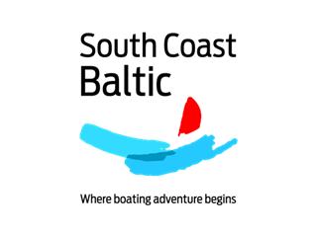

BOAT REGISTRATION FORM
SOUTH COAST BALTIC Boating Rally 2021
Bornholm - Zachodniopomorskie - Vorpommern
9 – 19 August 2021
Please fill in, scan & e-mail to info@southcoastbaltic.eu by 30 April 2021.
I will participate with my own ☐ Sailing boat
☐ Motor boat
Name of vessel:
Type of vessel / yard:
Year built:
Length over all:
Breadth:
Draught:
Engine : Power: kW HP
Port of registry:
Home port (during the season):
Flag:
Radio call sign:
Owner:
Skipper:
Address:
Phone:
E-mail:
Crew / no. of persons on board: (please fill in crew list, too – if possible)
Please help me to find a charter boat: ☐ Sailing boat
☐ Motor boat
Name:
Kind of boat searched for:
______________________________________________________________________
We plan to arrive in Svaneke on (day – dd.mm.)
We plan to leave from Kröslin on (day – dd.mm.)
We would like to offer a berth on our boat for a guest: ☐
Further comments or questions:

CONFIRMATION

With this I firmly register my boat & crew for the SOUTH COAST BALTIC Boating Rally 2021 Bornholm - Zachodniopomorskie - Vorpommern from 9 – 19 August 2021.

Participation fees:
- Fee per boat: 280 EUR
- Fee per person on board: 380 EUR
- Reduced fee / kids 6-14 years: 190 EUR
- Kids up to 6 years free of charge

Cancellation policy:
In case you have to cancel your participation, the organisers will first ask a boat from the reserve list to join. If no replacement can be found, the following cancellation fees apply:
- Cancellation until 30 April 2021: no fee
- Cancellation between 01 May – 30 June 2021: 50% of the participation fee
- Cancellation after 30 June 2021 / no show: 100% of participation fee
The cancellation fee is calculated on the total amount of the registration.
You may consider to take out a travel cancellation insurance, in order to avoid the fees.

Place, date, signature of skipper: _____________________________________

